1. The following env is used to do **login->** **security check->account overview->logout** PT:

<https://10.112.179.82:9444/nfs_tenpay/login.htm>

1. Open this url, then you can see the login page.

For **login.htm**:

There are no request body only header:

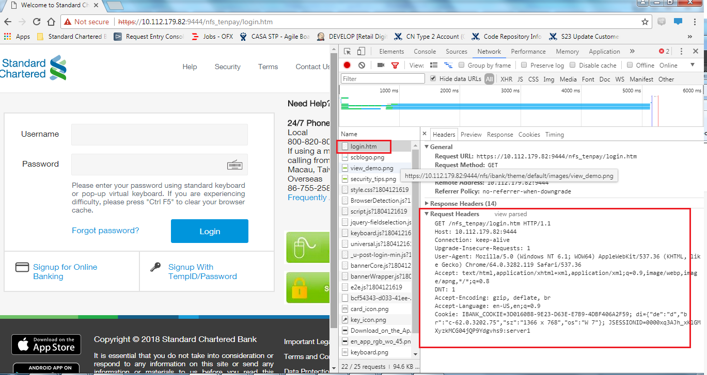

The response is the html for this page:

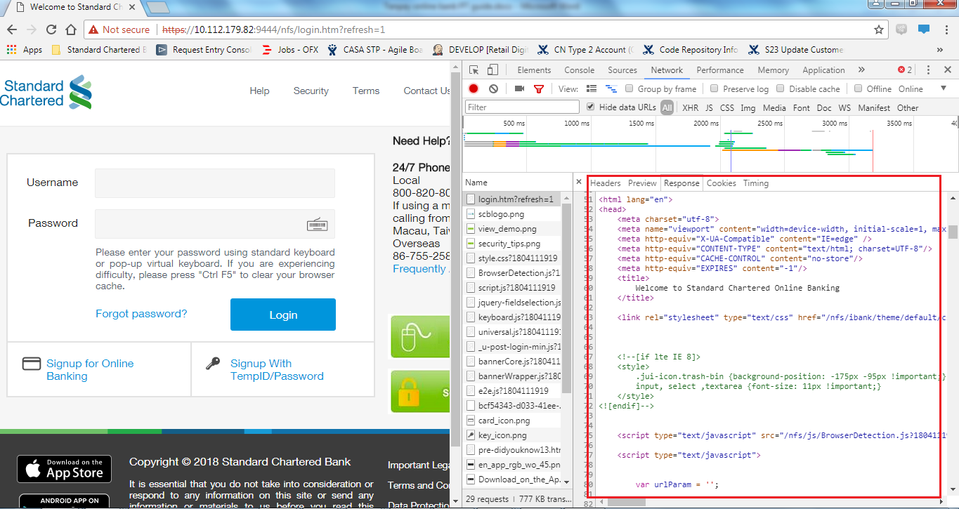

Then input username and password to login, then you can see the request for **security check.htm**

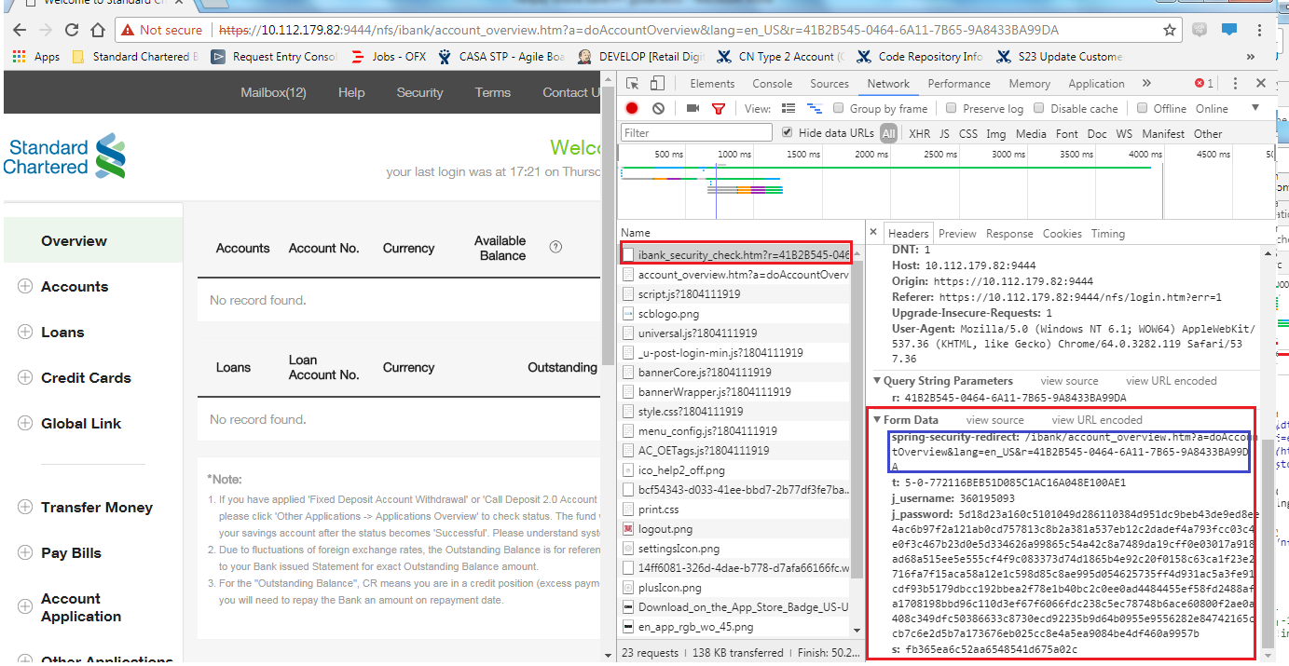

because this page is redirected to **account overview** page, there is no response.

you can see the request and response for **account_overview.htm**

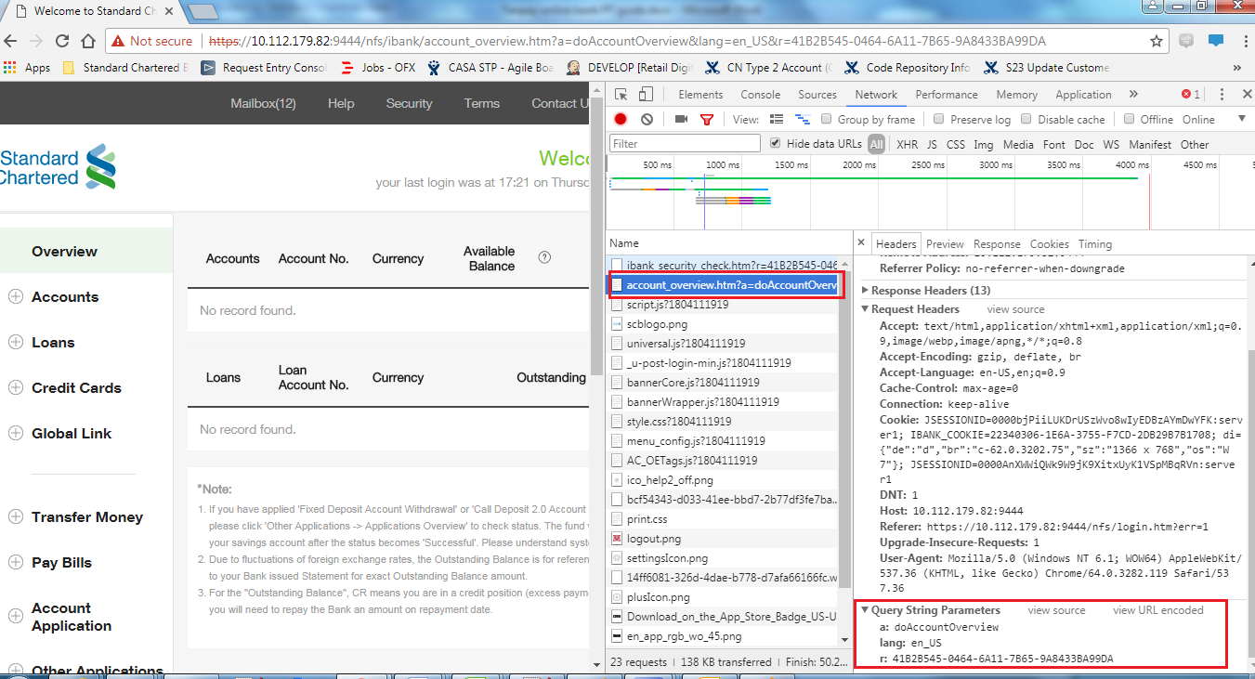

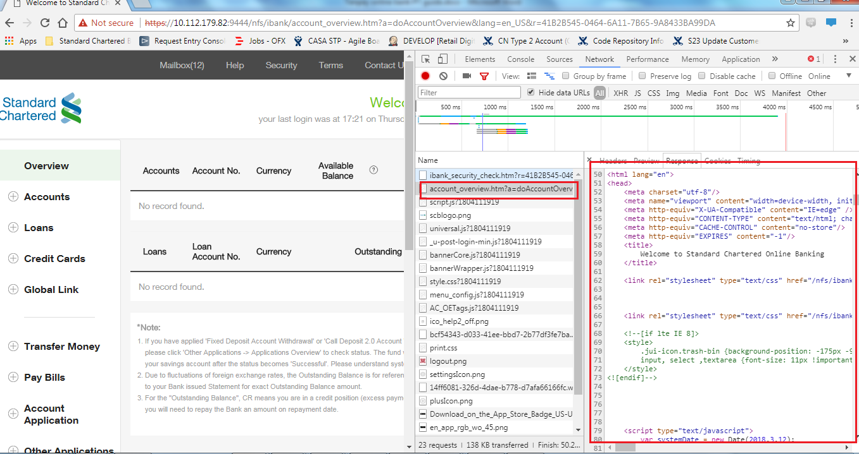

Then logout.

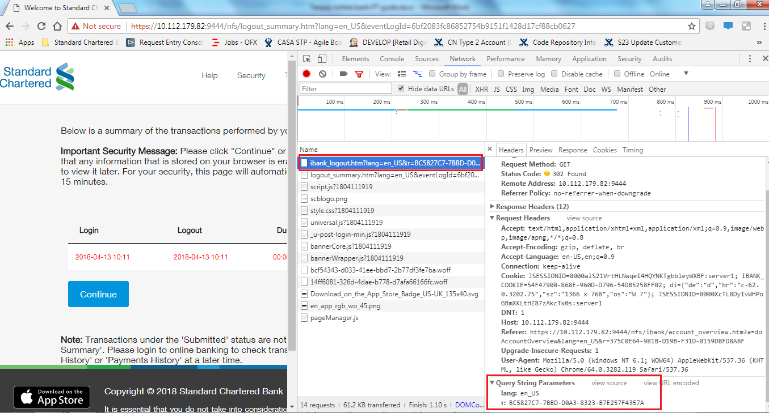

Through these request and response parameters we can get:

1. There are some stable parameters, such as “lang”;
2. There are also some changing parameters.

The parameter “password” need to be by pass because password in request is encrypted.

Do the parameters “s”& “t” represent “session” and “token”? If yes, they can be by pass.

What is the meaning of the parameter “r”, can it be by pass?

1. Setup PT script:
2. Add HTTP request Defaults:

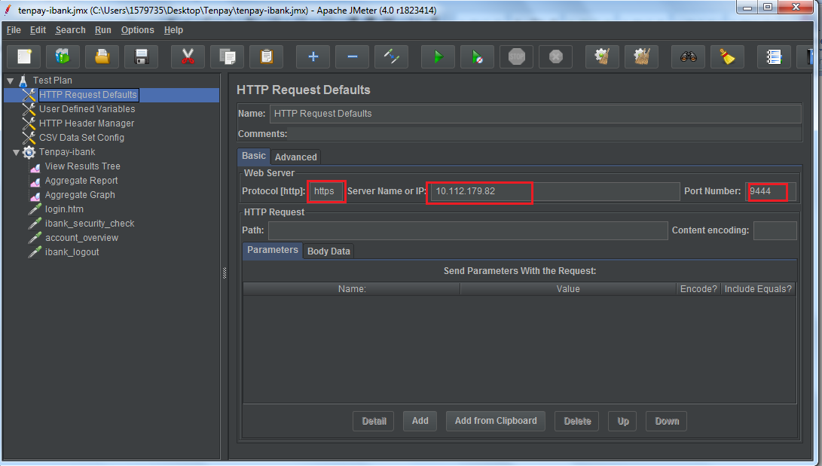

1. Add user defined Variable for these stable parameters:

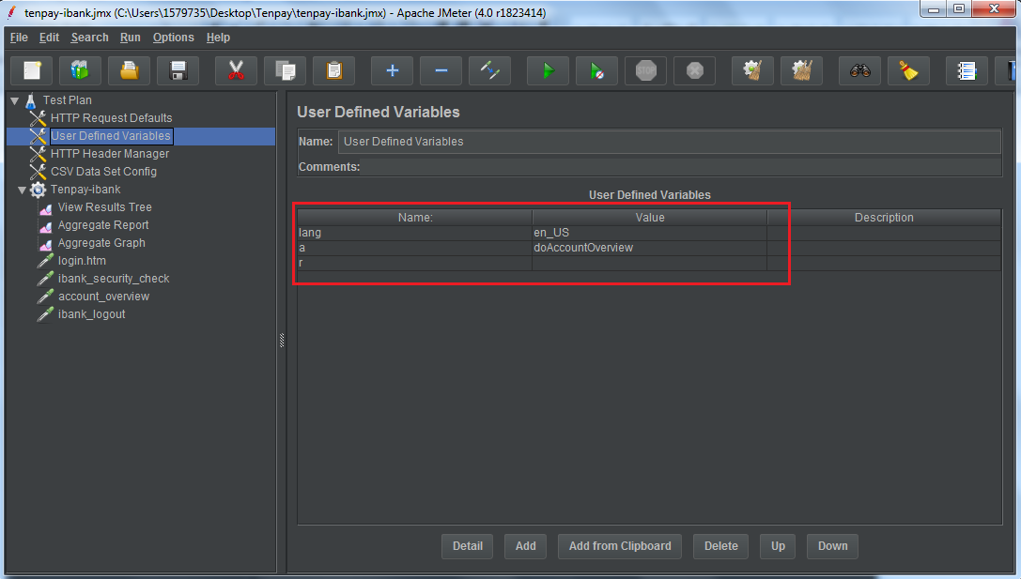

1. Add HTTP Header Manager:

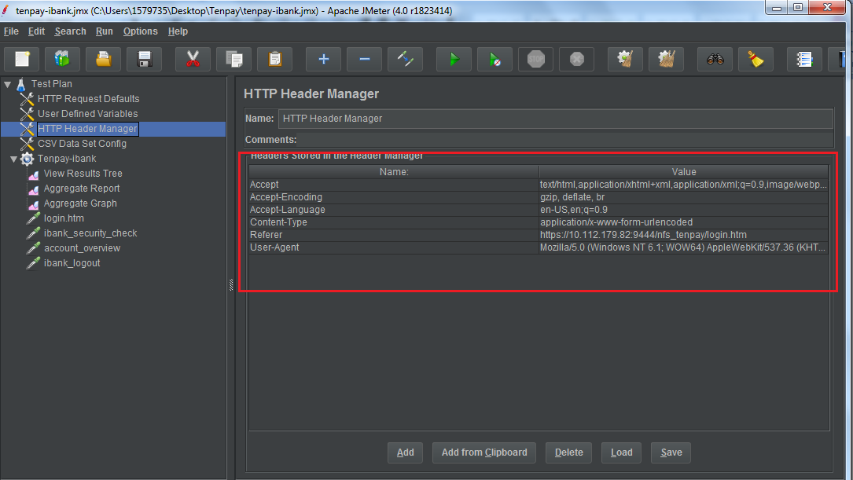

1. new a csv file and input the userId/password

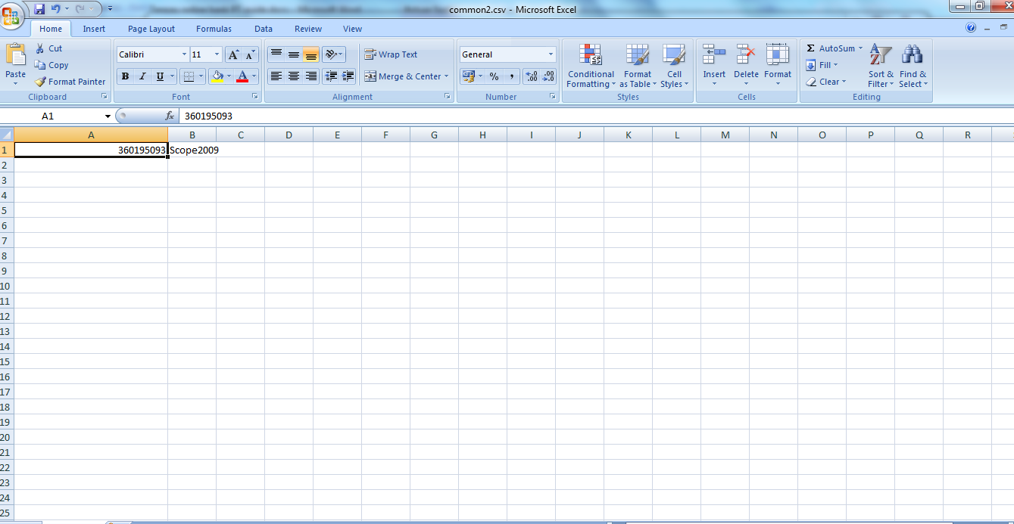

Add CSV Data Set Config and select the file path:

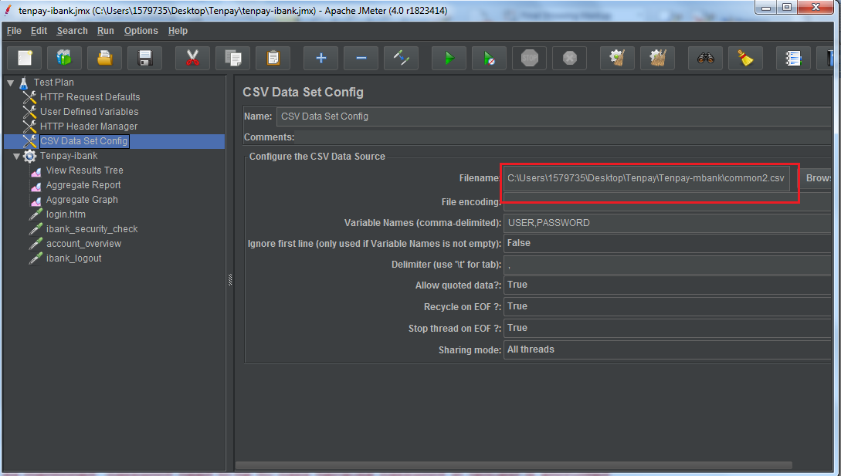

As mentioned, password need to be by pass because password in request is encrypted.

1. add Thread Group and you can set number of users, ramp-up period and loop count here.

add some listener to view the results:

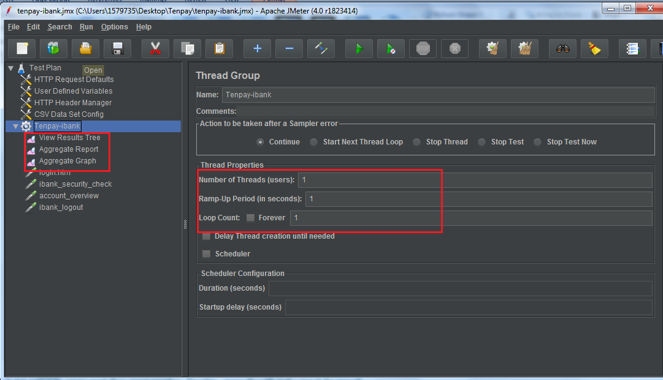

1. Add HTTP request for **login, ibank_security_check, account_overview** and **logout**.
2. the jmx script will be generated and next time you want to test this service, you can just drag the script to the box.